### **DVB Single Illumination Satellite for SFN Boost**

The subject of the contract will be the development of the basic part of the processing of digital television transport flows with APIs for subsequent connection with the user interface of process control and monitoring.

For compatibility with existing SW solutions, SW will be developed in the Linux operating system environment.

The Client shall make its infrastructure available to the Provider in order to enable the development of SW:

* Development servers
* HW equipped with specific I/O devices for TV signals (DVB-ASI, TSoIP, GbE)
* Digital TV signal generators at radio level and transport flow level
* Digital TV Signal Analyzers
* Satellite TV inputs
* Internet connection, VPN

The software will be integrated with other software within other activities.

The solution must be compatible with the technical standards and   
patents listed below, which were used in the creation of the DVB SIS standard by members of the DVB group.

* DVB-SIS Single Illumination satellite ETSI TS 103 615
* MPEG TS Information technology — Generic coding of moving pictures and associated audio information ISO 13 818
* [DVB-T2 Second Generation Terrestrial](https://dvb.org/?standard=frame-structure-channel-coding-and-modulation-for-a-second-generation-digital-terrestrial-television-broadcasting-system-dvb-t2) ETSI EN 302 755
* [DVB-T2-MI Second Generation Terrestrial-Modulator Interface](https://dvb.org/?standard=modulator-interface-t2-mi-for-a-second-generation-digital-terrestrial-television-broadcasting-system-dvb-t2) ETSI TS 102 773
* DVB-DATA Data broadcasting EN 301 192
* DVB-T First Generation Terrestrial Network [EN 300 744 V1.6.2](http://www.etsi.org/deliver/etsi_en/300700_300799/300744/01.06.02_60/en_300744v010602p.pdf)
* DVB-T-SFN (SFN) Single Frequency Network TS 101 191 V1.4.1

Mega-frame for Single Frequency Network synchronization

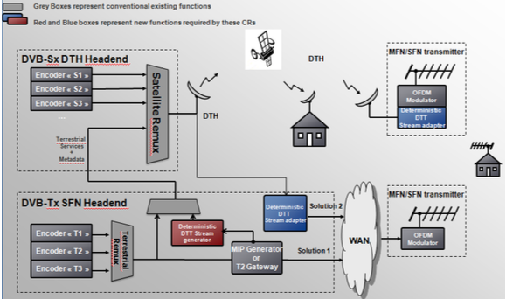

Figure 1 - Diagram of SFN BOOST distributed solution – in accordance with DVB SIS standard, state after implementation

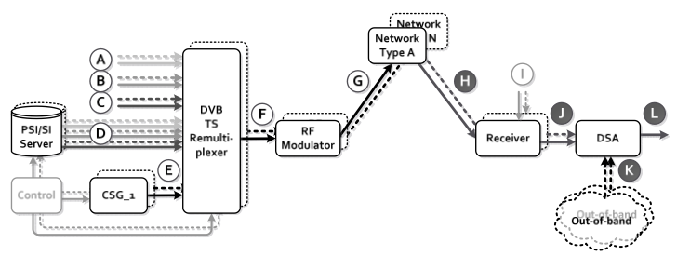

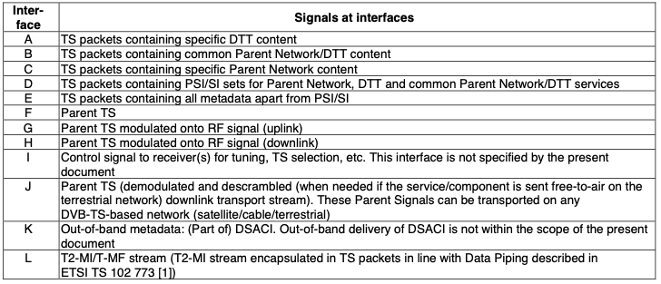

Figure 2 - DVB SIS transfer chain block diagram concept – target state after implementation

**Milestones:**

1. 20. December 2022 - CSG
2. January – March 2023 - DSA
3. April-June 2023

# Milestone #1 – 20.December 2022

1. Control Stream Adapter

This SW ensures the creation of a control flow that will allow deterministic generation of transport flows on terrestrial TV transmitters operating in single-frequency networks (SFN) in accordance with the "DVB Single Illumination Satellite" standard ETSI TS 103 615.

* 1. Layer 1 signaling support
     1. DVB-T2 transport stream

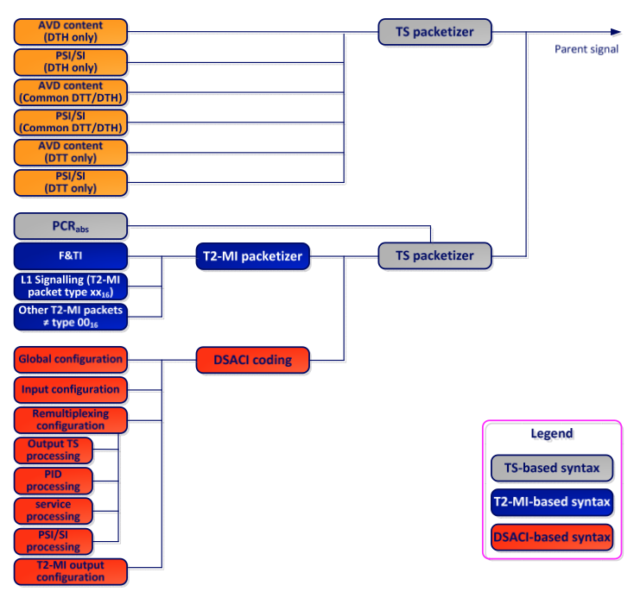

Figure 3 Parent signal composition illustrating metadata and audio video content in the case of DVB-T2 - target state after implementation

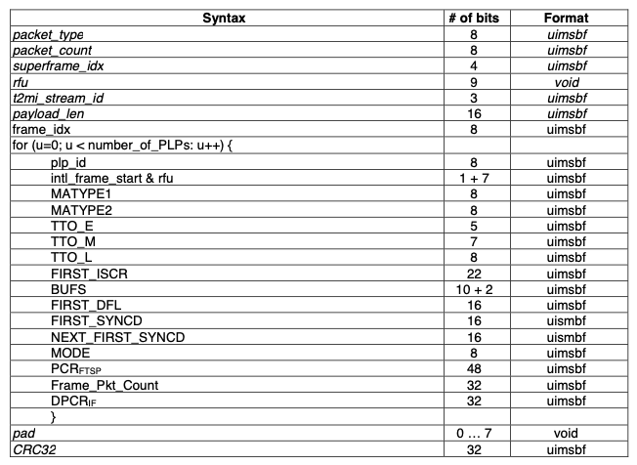

Figure 4 - Syntax and Frameworks and Time Information in DVB-T2   
– target state after implementation

* + 1. Support for Layer 1 DVB-T transport stream signaling

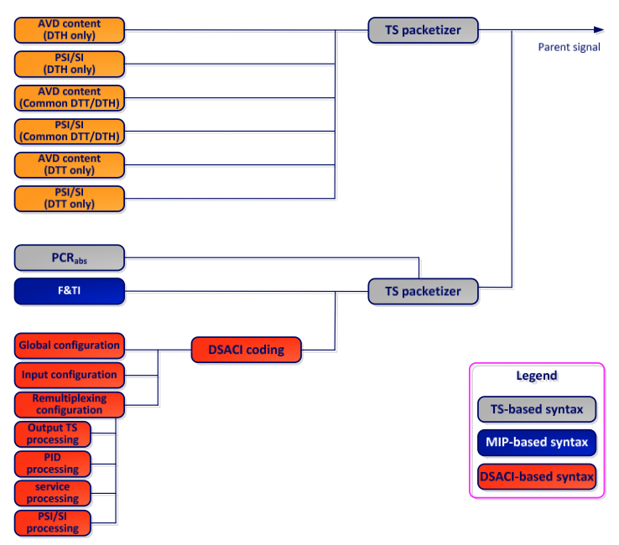

Figure 5 - Composition of the parent signal illustrating metadata   
and audio video content in the case of DVB-T -  
 target state after implementation

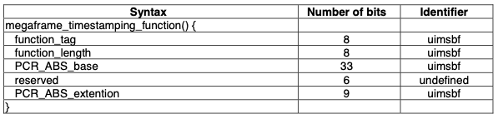

Figure 6 - Syntax of megaframe timestamping in DVB-T – target state after implementation

* 1. Support for other T2-MI packet types
  2. Framing & Timing information
     1. DVB-T2
     2. DVB-T
  3. DSA Configuration Information (DSACI)
     1. DSACI Structure
     2. XML types and XML elements
        1. Global configuration
        2. Input configuration
        3. Remultiplexing
        4. PID processing
        5. Service and PMT Processing
        6. PSI/SI processing
        7. PAT processing
        8. CAT processing
        9. SDT and BAT processing
        10. EIT processing
        11. Output configuration
     3. DSACI schema
     4. In-band carriage of the DSACI XML file

# Milestone #2 – January – March 2023

1. DSA - Daughter Site Adapter

This SW ensures deterministic generation of transport flows on terrestrial TV transmitters operating in single-frequency networks (SFN) in accordance with the "DVB Single Illumination Satellite" standard ETSI TS 103 615 based on the information contained in the control flow transmitted by the control flow adapter. The output signal must comply with the standards.

EN 302 755 DVB-T2 frame structure and channel coding

TS 102 883 T2-MI modulator interface

EN 300 744 DVB-T frame structure and channel coding

TS 101 191 SFN synchronization, Mega-frame

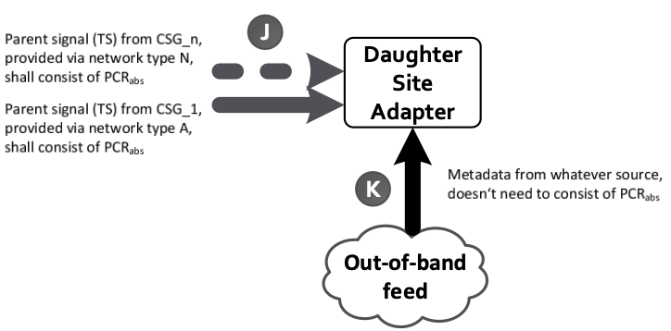

Figure 11 - Daughter adapter inputs - target state after execution

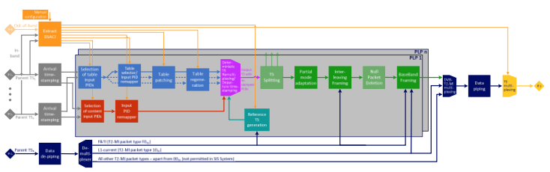

Figure 12 – DSA processing DVB-T2 – target state after implementation

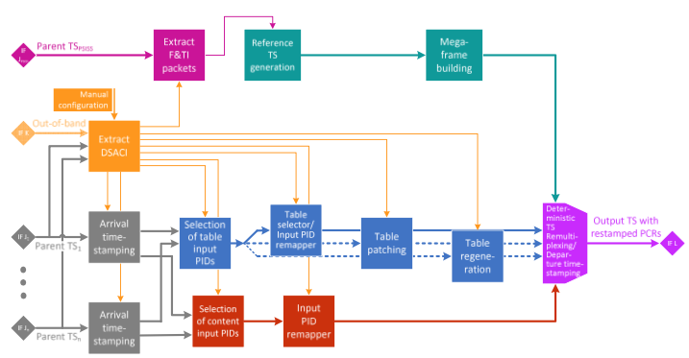

Figure 13 - DSA processing DVB-T– target state after implementation

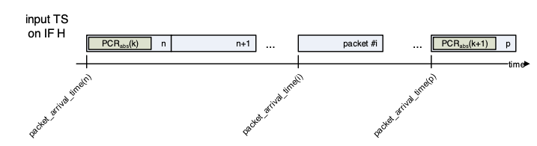

Figure 14 - Arrival timestamping mechanism – target state after implementation

* 1. Bootstraping  
     1. In band carriage of DSACI XML file
     2. Out of band feed
     3. Input of the flow of control metadata from an independent network.
  2. Input processing
     1. Reception of parent transport streams
        1. Arrival timestamping
        2. Calculation of Virtual Arrival Timestamps
  3. TS re-multiplexing
     1. Generation of Reference Transport Streams
        1. DVB-T2
        2. DVB-T
     2. Selection of relevant content from input TSs
     3. Processing and generation of Layer 2 signalling (PSI/SI)
        1. Pass-through
        2. Conversion of parent table/sections on the fuly
        3. Static table regeneration
           1. Dynamic table regeneration
           2. Placement of incoming packets in the outgoing TS

# Milestone #3 – March-June 2023

* 1. Framing  
     1. DVB-T2 case
        1. TS splitting
        2. Partial Mode Adaptation
        3. Allocation of TS bits to Interleaving Framces
        4. Null Packet deletion
        5. ISSY generation
        6. Generation of BBFRAMEs
     2. DVB-T case
  2. Extraction of T2-MI packets
  3. Output processing  
     1. DVB-T2 case
        1. T2-MI Multiplexing
        2. Transport of T2-MI packets in MPEG-TS
        3. Multi PLP output

This SW is supposed to reconstruct DVB-T2 transport streams in BBF (Baseband frames) format with support for 4 x PLP (Physical Layer Pipes) in accordance with EN 302 755 standard

* + - 1. Multi T2-MI output

ensures the generation of DVB-T2-MI (MI = modulator interface) transport flows in accordance with the TS 102 773 standard

* + 1. TSoIP output (transport flow via ip/internet)

This SW is supposed to broadcast at least 10 transport streams over the Internet in IP/UDP and IP/RTP packet format in accordance with the SMPTE 2022 digital television standard, which includes two-dimensional self-correcting encoding technology.

The input of the module is the transport flow in accordance with ISO 13818 -1and the output of the module IP stream in the sense of SMPTE 2022

* + 1. DVB-ASI output

This SW provides broadcasting via DVB ASI PCIe cards with min. 4 x DVB-ASI outputs in accordance with the TR 101 891 standard